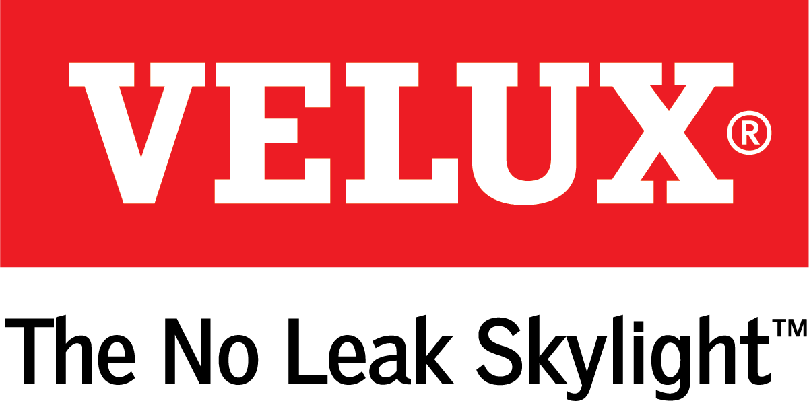
Media Contacts:
Kelsey Webb
704-790-1560
kwebb@wrayward.com

Dana Haydock
704-926-1301
dhaydock@wrayward.com

SUN TUNNELS PROVIDE A QUICK, INEXPENSIVE DESIGN UPGRADE
Product Qualifies for 30 Percent Federal Tax Credit with Solar Night Light Kit

LAS VEGAS, Feb. 19-21, 2019 – VELUX Sun Tunnels provide a quick and inexpensive home remodel option for bright, space-changing daylight and are now available with six decorative diffuser films and a sleek, modern ceiling ring that provides a soft glow. At night, a solar night light installed inside the reflective tunnel provides guiding light and enables the product to qualify for the 30 percent federal tax credit on solar property.
“Sun Tunnels allow sunlight directly into a room and provide a cost-effective option that makes living areas more comfortable and enjoyable,” said Ross Vandermark, national product manager for VELUX America. “And with the solar night light, Sun Tunnels work even harder by providing a moon-like glow to guide you when the sun goes down.”
Sun Tunnels can be customized with decorative diffuser films, available in six styles that complement many architectural designs:
- Micro Fresnel is a simple, yet effective design that provides unprecedented optical quality and focused light.
- Triple Wave consists of soft curves etched into the diffuser film that naturally diffuse the light while adding a unique design element to the Sun Tunnel Skylight.
- Much like the hardware in a home, Brushed Metal is a subtle yet effective option for enhancing the style of a room.
- The Prismatic design ensures that natural light is spread evenly throughout the room.
- The Bubbles design is perfect for homeowners who are looking to add an extra element of design to their fifth wall.
- Neutral Light converts daylight to appear more like a traditional household light bulb with a warm yellow bias.
For more information on purchasing and installing VELUX Sun Tunnels, visit veluxusa.com/products/sun-tunnels.

# # #

VELUX is the world leader in skylights and roof windows and is one of the strongest brands in the global building materials sector. VELUX America products are available nationwide through home centers, building material suppliers, lumberyards and independent door, window or roofing retailers. Consumers can locate local suppliers and installers and access information on skylight selection and the benefits of bringing more natural light and fresh air into the home by visiting www.veluxusa.com or www.whyskylights.com. VELUX skylights are made in America in Greenwood, South Carolina.

